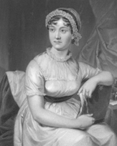 Have you thought about holding a

Jane Austen meeting?

You can find out more about Jane on the Jane Austen Society website **janeaustensociety.org.uk** which has a short but good biography about her.

The Jane Austen’s World website **janeaustensworld.com** includes details about the life of a Regency woman plus Regency links.

If you want to dress like Jane, a craft project could be to make a Regency bonnet. Abi Sue has a video about making a bonnet from a straw hat on [www.youtube.com/watch?v=_Ed36XI1Nks](http://www.youtube.com/watch?v=_Ed36XI1Nks)

[www.youtube.com/watch?v=Mp0e5GspNoM](http://www.youtube.com/watch?v=Mp0e5GspNoM) shows you how to make accessories to go with your costume in under 2 hrs, including another bonnet, jewellery, and reticule handbag,

Sotheby’s has a page about the secret language of fans, [www.sothebys.com/en/articles/the-secret-language-of-fans](http://www.sothebys.com/en/articles/the-secret-language-of-fans) which could you could try and then add to it with more modern massages.

Many local libraries and bookshops are beginning to have information, books and games about Jane, such as

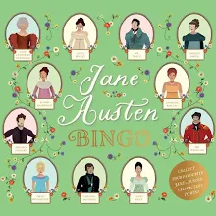Jane Austen Bingo

by [Barry Falls](https://www.tgjonesonline.co.uk/Search/Search?Author=Barry%20Falls), [John Mullan](https://www.tgjonesonline.co.uk/Search/Search?Author=John%20Mullan)

Illustrated by [Barry Falls](https://www.tgjonesonline.co.uk/Search/Search?Contributor=Barry%20Falls)

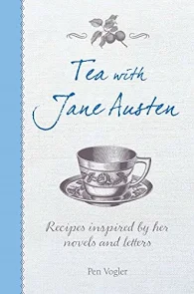‘Tea with Jane Austen:

Recipes inspired by her

novels and letters’

by Pen Vogler.